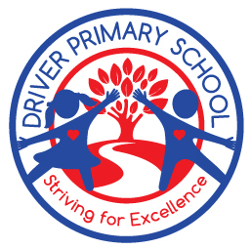

Parent
Information
Booklet

We believe in educating the whole child, the head, the heart and the hands.

Driver Directions
At Driver Primary School we believe in educating the whole child, the head, the heart and the hands.
Often referred to as Driver Directions, our students learn about our school values and the characteristics of a good learner.
‘Captain RECS’ helps us promote wellbeing and positive behaviour through the Driver Primary School Values:

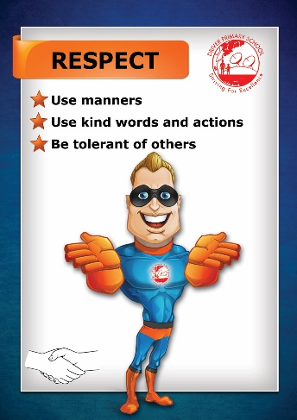
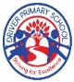
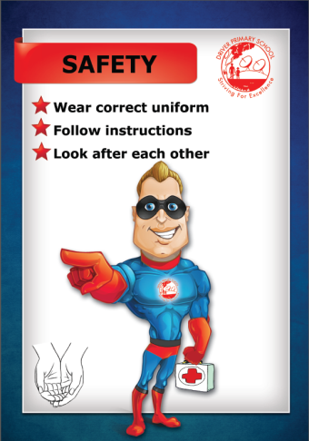
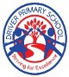
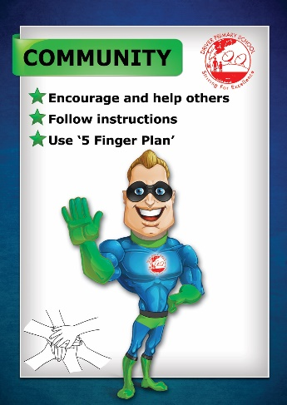
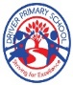
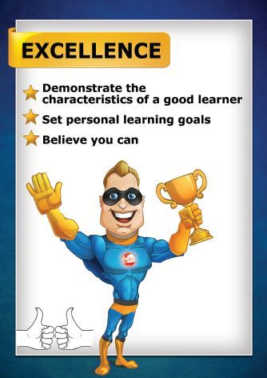
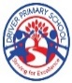

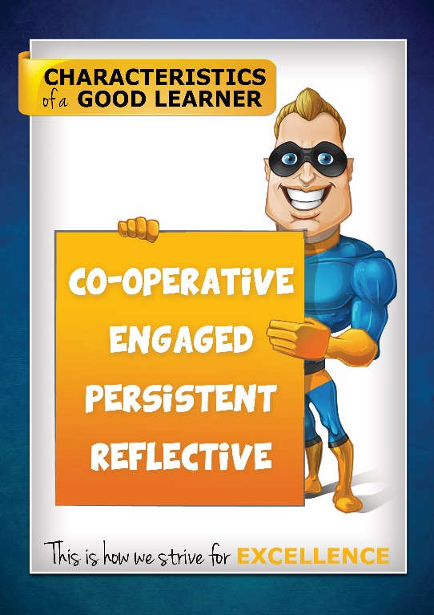
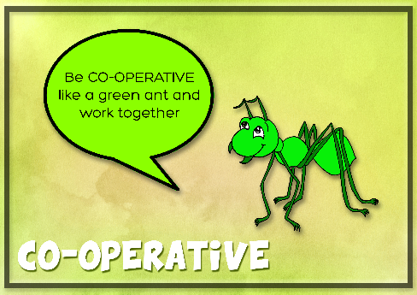

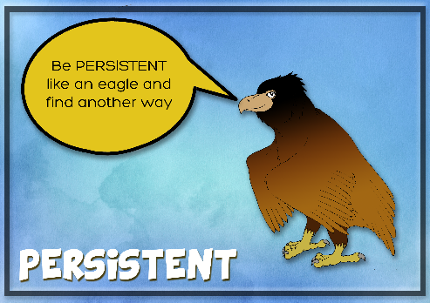
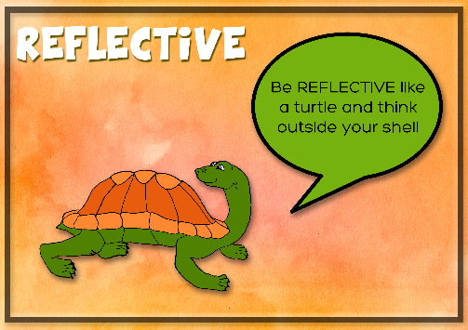
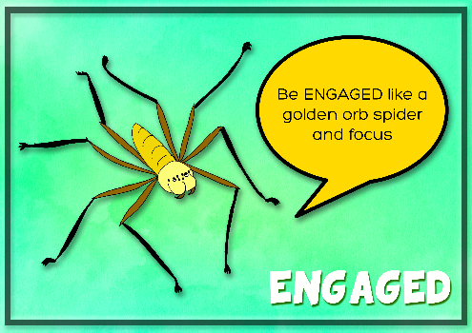

A regular day at Driver Primary

7:50am | School gates open, supervision available in inner area
8:15am | Music plays and class doors open
8:20am – 9:20am | Lesson one
9:20am – 10:20am | Lesson two
10:20am – 10:40am | Recess play
10:40am – 10:50am | Supervised eating in class
10:50am – 11:50am | Lesson three
11:50am – 12:50pm | Lesson four
12:50pm – 1:20pm | Lunch play
1:20pm – 1:30pm | Supervised eating in class
1:30pm – 2:30pm | Lesson five
2:30pm – 2:50pm | End of school day. Students released. Transition students need to be collected from class.  Kiss and Go open with supervision from 2:30pm – 2:50pm

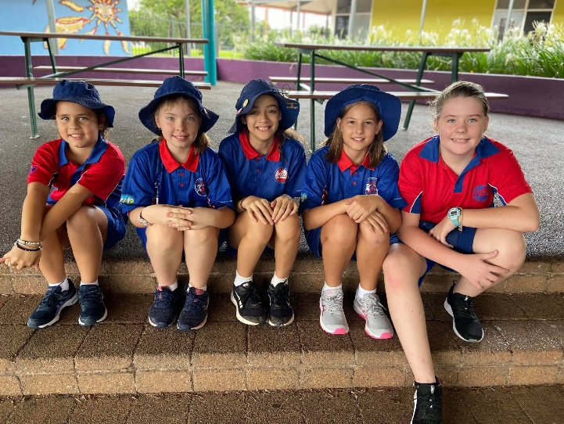

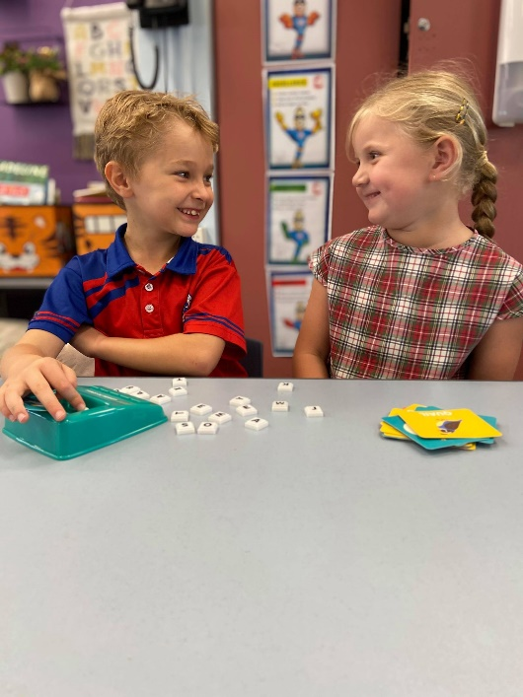

Driver Primary provide supervision of students from 7:50am until 2:50pm
Outside these hours, children’s safety is a parental/guardian responsibility.
If you require care outside of school hours, the YMCA run an onsite OSHC program with before school, after school, pupil free day and vacation care options.

For bookings and more information visit: osch.nt.ymca.org.au
Or contact: driver.oshc@ynt.org.au

Teaching and Learning

2-Hours of Literacy a day
Our school follows a structured literacy approach. Teachers explicitly teach reading, spelling, and writing through phonemic awareness, phonics, fluency, vocabulary, language structures, and comprehension. Students engage in daily, systematic lessons that build strong foundations in decoding and understanding text, ensuring every child becomes a confident and capable reader and writer.

Mathematics
Our school follows the Meaningful Maths approach, which focuses on helping students understand why maths works, not just how to do it. Lessons are hands-on, engaging, and build strong number sense through reasoning, problem-solving, and real-life connections.

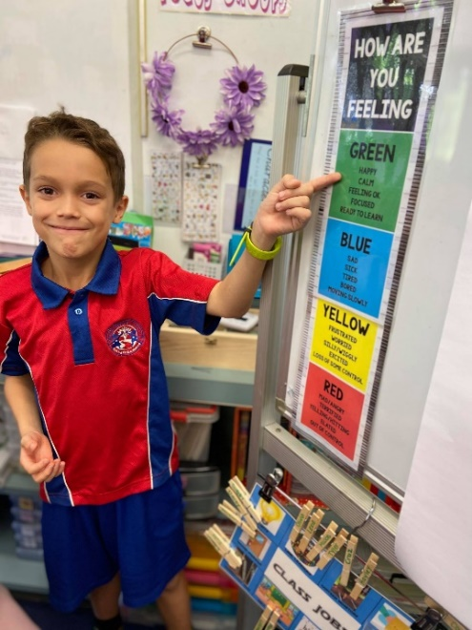
Zones of Regulation is a program our school uses to help students recognise, understand, and manage their emotions. It uses four colour zones to describe how we feel and how our bodies are running:
- 🟦 Blue Zone – Sad, tired, sick, or bored (low energy)
- 🟩 Green Zone – Happy, calm, focused, and ready to learn
- 🟨 Yellow Zone – Frustrated, silly, worried, or excited (losing some control)
- 🟥 Red Zone – Angry, out of control, or overwhelmed
Students learn strategies to move between zones to help them regulate their emotions and build resilience. No emotion is a bad emotion — it’s normal for everyone to experience a range of feelings each day.

Other Learning Areas
Farm and Kitchen Program: Our Farm and Kitchen Program gives students hands-on skills in growing, harvesting, preparing, and sharing fresh food. It has strong connections to science through real life learning and experiences. It encourages healthy eating habits, teamwork, and respect for the environment.

Health and Physical Education: Our school has a strong focus on Health and Physical Education, supporting students to build fitness, coordination, and confidence through a wide range of physical activities. Lessons also promote wellbeing, teamwork, resilience, and making healthy lifestyle choices.

Compulsory School Uniform
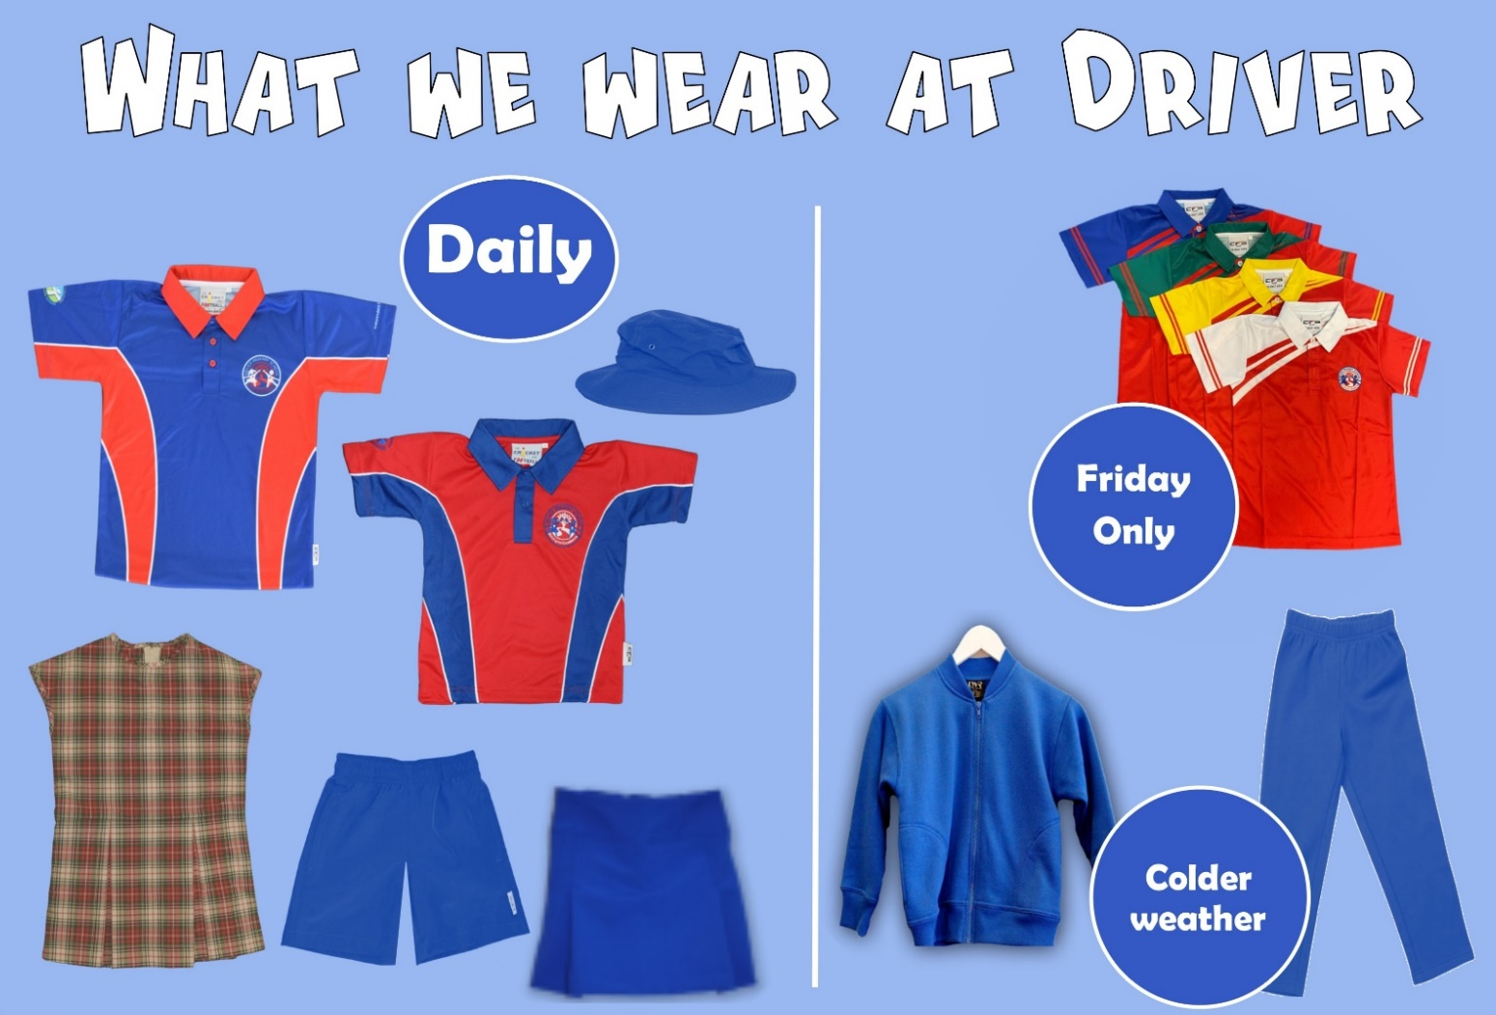

Students must wear the Driver Primary School shirt with royal blue shorts, skorts or a skirt, or the Driver Primary dress. Year 6 students are encouraged to wear the Year 6 Driver shirt. School House Shirts can be worn on Fridays only, however, are not compulsory.
​
In cooler weather:
- A plain royal blue jumper/jacket over the uniform shirt is permitted. Hoodies are not permitted.
- Plain royal blue long pants may be worn in place of bottoms.
​
Students are required to wear a plain royal blue bucket hat whenever they are outside. Baseball caps are not considered sun protective and are therefore not permitted.

Alternative undercover play options are available if a student does not have a school hat but is otherwise in uniform.
​
Sneakers or closed toe shoes are required for all students. For safety reasons thongs, crocs and open toe shoes are not acceptable footwear for school.

Parents will be contacted if students are out of uniform or repeatedly do not have the school hat.

It is important to maintain this dress code and we thank you for your support.

Uniforms are for sale at the front office.

Please ensure that uniforms and hats are clearly labelled with your child’s name.

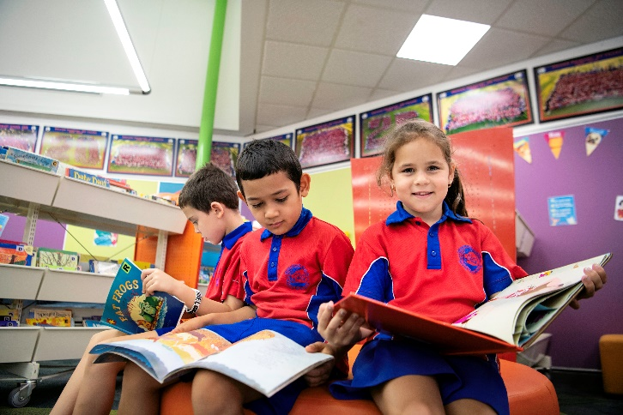
Homework
At our school, we recognise that reading is a vital life-long skill. To support the development of strong reading habits, teachers will assign reading-only homework throughout the year.

We encourage all students to dedicate time each evening to reading. For emerging readers, this may include practising sight words, while more confident readers may engage in comprehension tasks to help them progress toward their individual reading goals.

Please see the Classroom Teacher if you would like further information or support with your child’s reading.

Toys and Electronic Devices
Toys and electronic devices from home are not permitted at school. Toys from home will be confiscated until the end of the day. Parents will be contacted if students continue to bring toys or devices.

E-Bikes and E-Scooters
Electric scooters laws stipulate that they should not be used for transport to school by staff or students. However, electric bicycles are permitted.
- e-scooters are not permitted on school grounds at any time
- e-bikes are permitted but must remain outside

Mobile Phones

Student mobile phones are not permitted to be used in Northern Territory government schools.

Students from Preschool to Year 6 are not permitted to have their mobile phones in their possession during the school day. If students have a phone, it must be turned off before entering the school and taken to the office for safe collection until the end of the day. Student phones must remain off until they have left school grounds.

Exemptions are available for students who are required to monitor a health condition, and a health care plan has been developed with the school.

Ways We Play at Driver
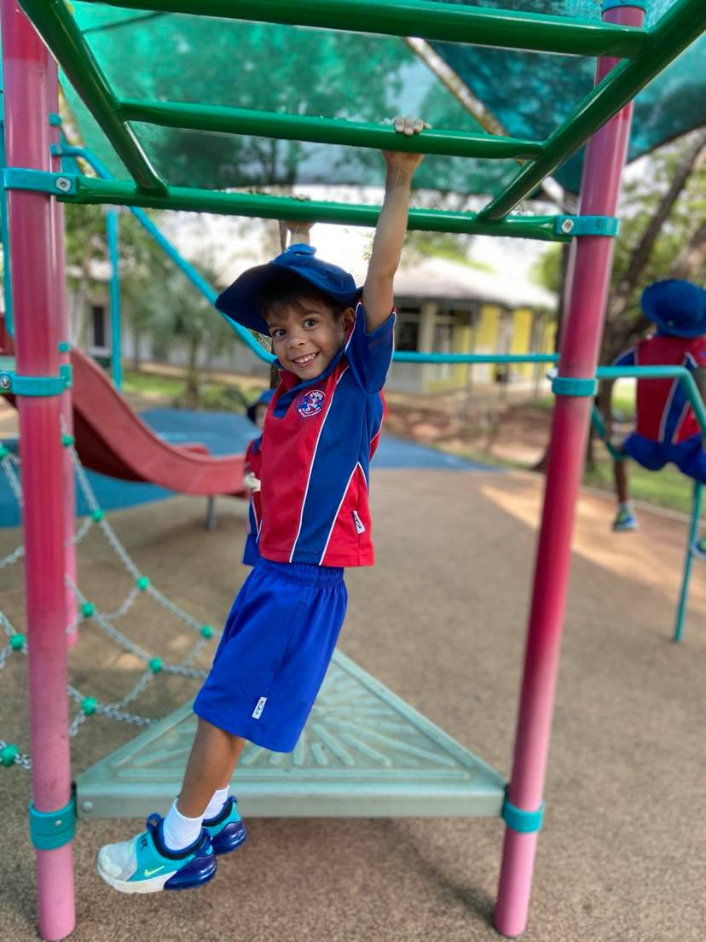
Early Childhood Learning Environment (ECLE)
Complete with a permanent playground, a fossil sandpit, a shallow creek feature, cubby house, magnet wall and an assortment of equipment on rotation, our Transition yard is a safe and exciting place to play for our students in their first year of Primary School.

Recess and Lunch Clubs
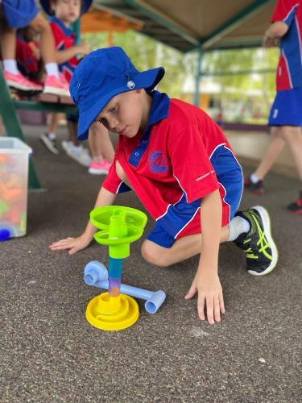
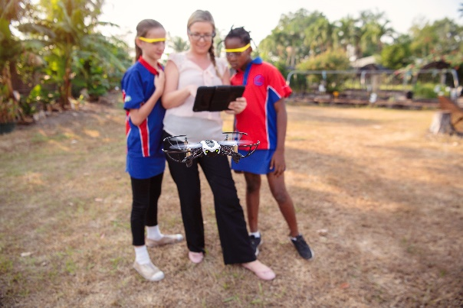
A mix of recess and lunch clubs are available throughout the school. These clubs, which are based on student interest, may include: Choir, STEM Club, Pop-up Playground, Maker Space, Dance, Computer Club and Sport. Checkout the flyer in the noticeboard by the Library for what’s on this Term.

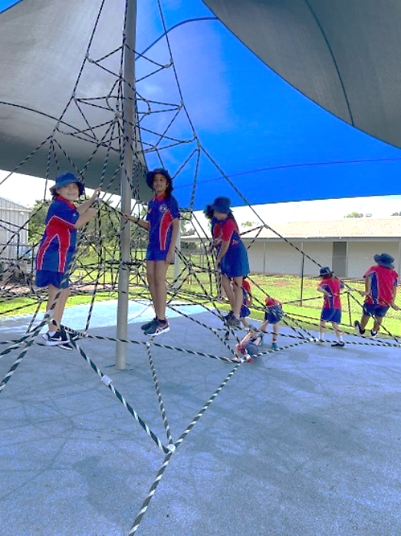

Stars and Clontarf
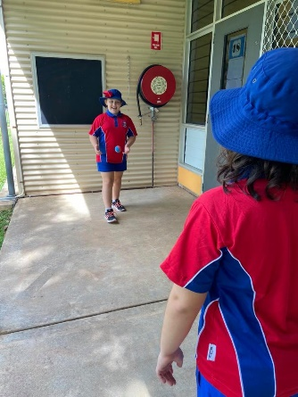
The Stars and Clontarf rooms are open to all Years 3-6 students at recess and for members at lunch. Stars room is for our female students and Clontarf is for the male students.

Peer Group Play Areas
For students in Years 1-6 we have a range of permanent playgrounds, grassed ball areas, basketball hoops and zoned 4-square courts for students to play together in their peer groups.

Awards
We have 2 rewards systems to acknowledge and reward exemplary behaviour and improving choices both in the classroom and the playground.
- Whole school in class reward system:

Merit Awards - Recognition at whole school assembly.
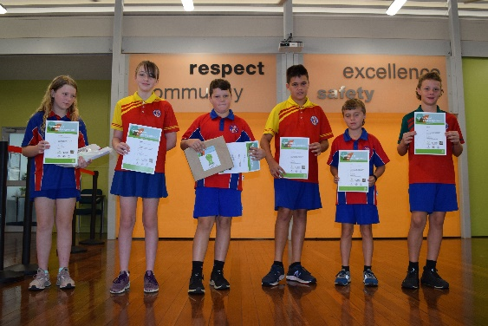
Principal’s Award - Recognition at whole school assembly for receiving five Maxi Merit awards. A Principal’s morning tea is held after the last assembly of each term for that term’s recipients.

Parents will receive an invitation to attend assembly if their child is receiving an award.
- Whole school playground reward system:

Caught Being Good tickets are given to students who make positive choices aligned to the school’s values of Excellence, Respect, Safety and Community in the playground. We also reward students for being ‘Ready Set Go’ for learning time, when lining up for class. A raffle is held during assemblies where students have the chance to win a prize.
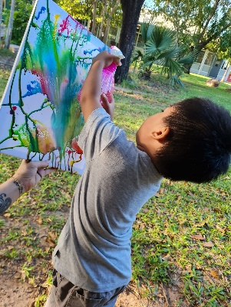
Playgroup
Driver Primary School offers a free Playgroup service to all families within the Northern Territory. No registration required.
Our friendly Educators hold Play and Learn Playgroup weekly, for 0–5-year-olds, during school terms.
Pick up a flyer from the front office and checkout our Facebook page for updates.
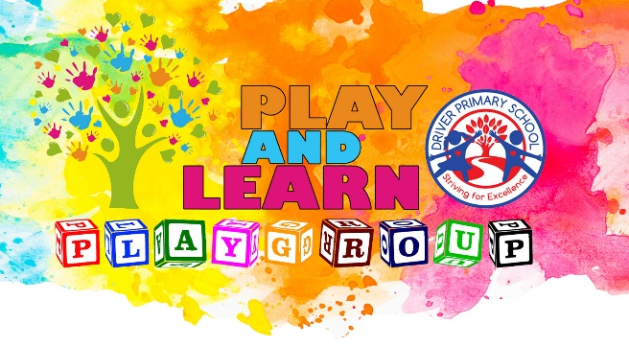
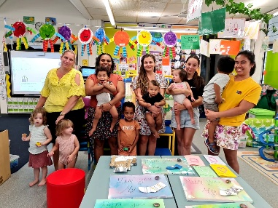

Canteen

Recess and lunch orders can be made by visiting the canteen before school, writing an order on a paper bag with cash inside or by ordering on the Spriggy Schools App.

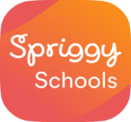
Spriggy Schools is a convenient online ordering system for recess and lunch orders at our school canteen. Orders can be placed via the Spriggy Schools app or at www.spriggyschools.com.au until 9am on the day of your order and up to 2 weeks in advance.

Go to www.spriggyschools.com.au to register or download the app to your phone.
- Add a profile for each of your children, making sure you select Driver Primary School and your child’s class.
- Start placing online recess and/or lunch orders!

Stay in Touch
School to Home Communication
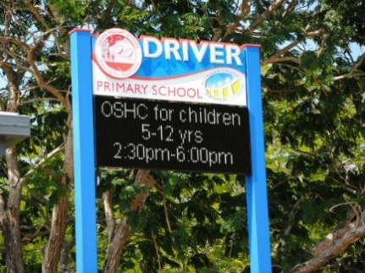
Communication is primarily sent home electronically via Xuno. Once your child’s enrolment is complete and the consent form signed, you will receive an email with instructions on how to access Xuno.

Our electronic sign at the front of the
school is regularly updated with our school events.


Find and follow us on Facebook
@driverprimaryschool

Check out our website at
www.driverprimary.nt.edu.au

DRIVER PRIMARY SCHOOL
37 Driver Ave Driver NT 0830
PO Box 33 Palmerston NT 0831

General Enquiries and
Reporting Student Absences:
8935 9000
admin.driverprimary@education.nt.gov.au



